

**Project**

**From “Software Development Techniques”**

**Instructor**: **Students**:

Alishokh Taigunshoev w62882  
 Ardasher Mamadrizobekov w63447

# Table of Content

1. Technologies  
   1.1. React.Js  
   1.2. Node.Js/Express  
   1.3. MySQL
2. Application Architecture
   1. Frontend
   2. Backend
   3. Database
3. Application Description
   1. Basic Description
   2. Functionalities
4. User Interface
   1. Login
   2. Create Account
   3. Forgot Password
   4. User
   5. Expenses
5. Summary
6. Technologies
   1. React

React, developed and maintained by Facebook, is a powerful and flexible JavaScript library primarily used for building user interfaces, especially for single-page applications where a seamless user experience is essential. Released in 2013, React has since become one of the most popular front-end frameworks due to its component-based architecture, virtual DOM, and unidirectional data flow. At the core of React are components, which are reusable and independent pieces of code that represent parts of the user interface. These components can be nested, managed, and handled separately, making development more manageable and scalable. Each component can maintain its own state, which allows for dynamic and interactive UI elements. React's virtual DOM is another standout feature. Instead of updating the entire web page when changes occur, React updates only the parts of the DOM that need to be changed. This approach enhances performance, particularly for applications with complex and frequent UI updates. The unidirectional data flow in React simplifies the debugging process and ensures that data changes in a predictable manner. This is achieved through properties (props) and state management. Props allow data to be passed from parent to child components, while the state allows components to manage and respond to their own data changes internally. React also leverages a rich ecosystem of tools and libraries, such as Redux for state management, React Router for navigation, and various middleware for handling asynchronous actions. This extensibility enables developers to tailor their applications precisely to their needs. In summary, React's innovative approach to UI development, performance optimization through the virtual DOM, and robust ecosystem make it an indispensable tool for modern web developers aiming to create efficient, dynamic, and maintainable web applications.

* 1. Npde.js/Express

Node.js, introduced by Ryan Dahl in 2009, is an open-source, cross-platform JavaScript runtime environment that allows developers to run JavaScript on the server side. It is built on Google Chrome's V8 JavaScript engine, making it highly performant and efficient. Node.js is renowned for its non-blocking, event-driven architecture, which makes it particularly suitable for building scalable and high-performance applications, especially real-time applications like chat apps, online gaming, and collaborative tools. One of the standout features of Node.js is its single-threaded event loop, which enables it to handle multiple concurrent connections with minimal overhead. This is in contrast to traditional server models that create a new thread for each connection, which can be resource-intensive. With Node.js, developers can build servers that can handle a large number of simultaneous connections efficiently. Express.js, often simply referred to as Express, is a minimal and flexible Node.js web application framework that provides a robust set of features to develop web and mobile applications. It simplifies the server creation process and provides a comprehensive set of HTTP utility methods and middleware, making it easier to build robust APIs and web servers. Express follows a minimalist design philosophy, offering a thin layer of fundamental web application features without obscuring Node.js features. This allows developers to have full control over the application architecture while leveraging middleware to handle common web development tasks such as request parsing, cookie management, and session handling. The combination of Node.js and Express enables developers to use JavaScript end-to-end for both client-side and server-side development, streamlining the development process and enhancing productivity. This unified language environment allows for easier knowledge transfer and code sharing between front-end and back-end development teams. In summary, Node.js and Express together form a powerful duo for building efficient, scalable, and maintainable server-side applications. Their performance, flexibility, and extensive ecosystem make them a popular choice for modern web development.

* 1. MySQL

MySQL, an open-source relational database management system (RDBMS), is a cornerstone of many web applications and services. Originally developed by MySQL AB in 1995 and later acquired by Oracle Corporation, MySQL has become one of the most widely used databases due to its reliability, performance, and ease of use. At its core, MySQL utilizes Structured Query Language (SQL) for database management and operations. SQL is a powerful and intuitive language for querying, updating, and managing data, making MySQL accessible to both new and experienced developers. MySQL supports a broad range of SQL functionalities, including transactions, subqueries, and joins, allowing for complex and efficient data manipulation. One of the key strengths of MySQL is its performance. It is designed to handle high-volume, concurrent database operations with low latency. This makes it an excellent choice for web applications that require quick read and write operations, such as content management systems (CMS), e-commerce platforms, and social media applications. MySQL's storage engines, such as InnoDB, provide robust transaction support, ensuring data integrity and reliability through ACID (Atomicity, Consistency, Isolation, Durability) compliance. MySQL is also highly scalable, capable of managing large databases with millions of records. It supports replication, allowing data to be mirrored across multiple servers for load balancing and high availability. Additionally, MySQL's compatibility with numerous platforms, including Windows, Linux, and macOS, and its integration with popular programming languages such as PHP, Python, and Java, make it a versatile and flexible choice for developers. The MySQL community edition is free and open-source, which fosters a large and active community that contributes to its continuous improvement and offers extensive support through forums, documentation, and third-party tools. For enterprise needs, Oracle offers commercial versions with advanced features, professional support, and enhanced security. In summary, MySQL's blend of performance, scalability, and ease of use makes it a trusted and essential component for a wide range of database applications, from small-scale projects to large, complex enterprise solutions.

1. Application Architecture
   1. Frontend

Frontend part has been written in React using some other libraries so as to implement and efficient solution of well-known business tasks. The Structure of the Frontend looks like as presents the following picture:  
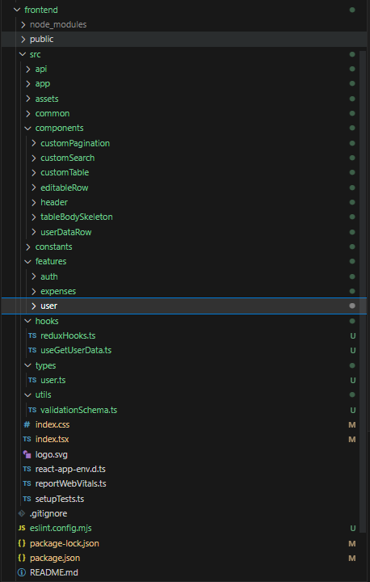  
Main root app starts from index.tsx file where we render the App.tsx file in app folder, in that file we have the routing for the whole application restricted in a way that unauthorized user will not have access to the app. Api folder is responsible for communication between frontend and backend using axios library. Assets Common and Constants folders contain some additional pictures or values that are used in multiple places. Components folder has main components which are used to build the feature pages. Feature folder is the folder devided into three sections user folder auth folder and expenses. User folder is related to the account and allows user to view and edit their data. Auth folder is responsible for log in, creation of new account and reset the forgotten password. Expense folder is the folder with the main features of the application where user is able to add delete and edit expense, filter the results and view it in the table as well as download filtered in the table results to PDF format. Hooks folder has custom react hooks that are used in multiple places, types and utils folder are basically store the commonly used files and function used in the project.

* 1. Backend

Backend side has been written using Node.js/Express and has the following structure:  
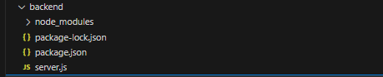  
  
node modules is the folder where all the necessary dependencies of the project are installed it can be viewed from package.json file. Server.js file has got the whole backend logic with REST endpoints and database connection.

* 1. Database

Database for this project was used MySQL database run locally through XAMPP phpMyAdmin service.  
the structure of the Database looks like as presented on the picture below:   
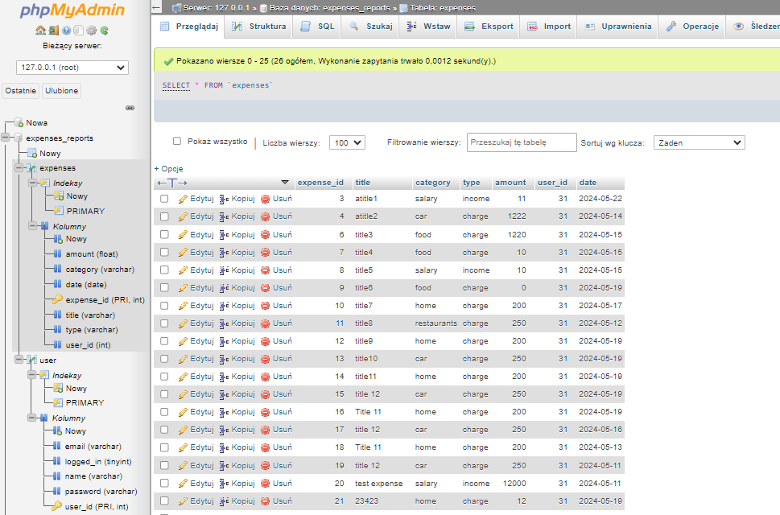

Database consist of two tables expenses and users. Expenses tables stores the data related to the expense its type date title amount category and user id which is the unique primary key in the user table. User table stores the data related to the user accounts.

1. Application Description
   1. Basic Description

An expense application serves as a powerful tool for individuals to effectively manage their finances by tracking their spending habits and budgeting more efficiently. This user-friendly software allows users to log their expenses, categorize them based on predefined categories or custom tags, and monitor their income and expenditures in real-time. With the ability to set financial goals and spending limits, users can stay on track with their financial plans and avoid overspending. The application empowers users by providing them with detailed insights into their spending patterns and habits. By visualizing their expenses through interactive charts and graphs, users can identify areas where they may be overspending and make informed decisions to adjust their budget accordingly. Additionally, the app may offer personalized recommendations and financial tips to help users optimize their spending and savings. One of the key features of an expense application is the ability to generate detailed reports that provide a comprehensive overview of the user's financial activities. Users can filter and customize these reports based on criteria such as date range, expense categories, and income sources. Moreover, the application may offer the functionality to export these reports PDF format, enabling users to further analyze their financial data or share it with financial advisors. Overall, an expense application is an invaluable tool for individuals seeking to take control of their finances, improve their financial literacy, and work towards achieving their long-term financial goals. By leveraging the insights and tools provided by the application, users can cultivate healthy financial habits and make smarter financial choices to secure their financial future.

* 1. Functionalities
* Create Account: Users can create an account by providing necessary information such as username, email, and password.
* Edit Account Data: Users can edit their account information, including username and email address.
* Reset Password: Users can request a password reset if they forget their current password. This usually involves sending a password reset link to the user's email address.
* Add and Edit Expense or Income: Users can add their expenses and incomes to the system by providing details such as amount, type of expense/income, and date.
* Filter Report Results: Users can filter the expense and income report results based on criteria such as date range, amount range, and type of expense/income.
* Download Report in PDF: Users can download the filtered expense and income report in PDF format for their records or further analysis.

1. User Interface
   1. Login

Login page is the main entrance to the application and unauthorized access is restricted which means that user Is not able to use the app before the login process.  
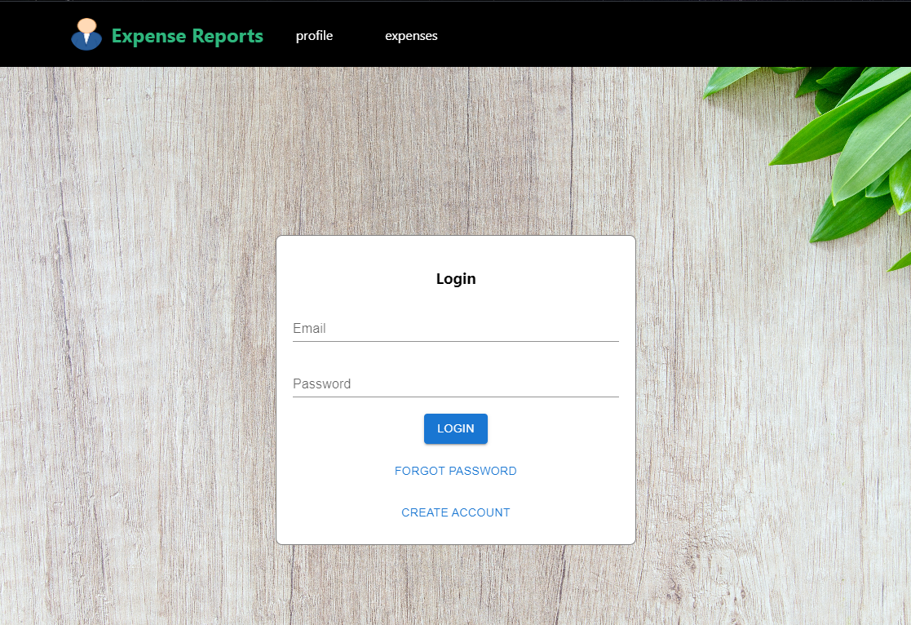  
here user can navigate to create a new account or to reset the password in case he forgot his password.

* 1. Create Account

Create new account page collects the user data validates it and sends it to the backend where all the data will be saved to the database after creation a new account user will be automatically redirected to the login page.  
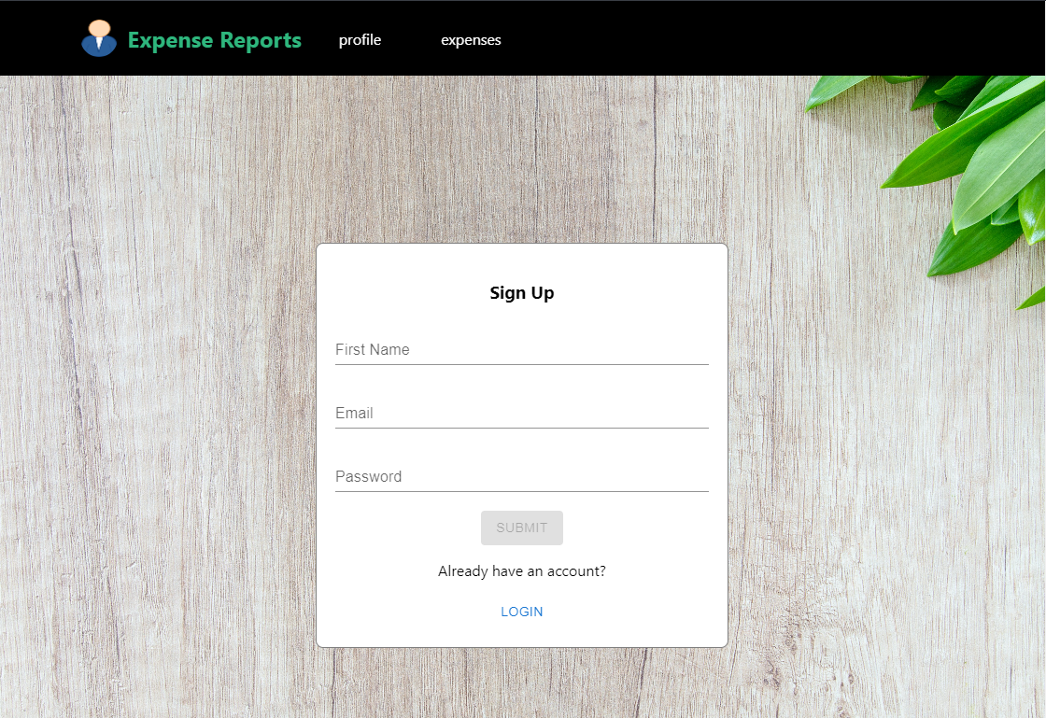

* 1. Forgot Password

Forgot password page require the user to provide his email to which there will be send the temporarily password which user will able to use and change once he is logged in to the application.  
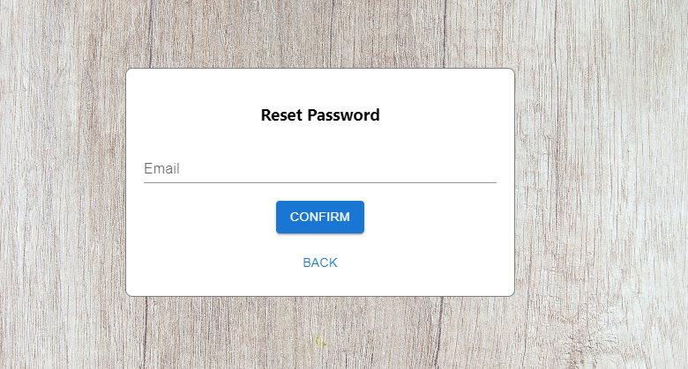

* 1. User

User Data page looks like as presented on the picture below:  
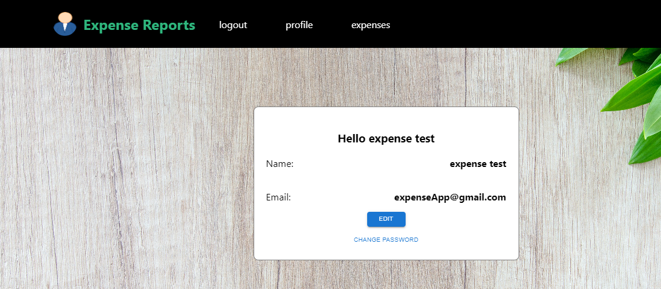  
and allows user to edit their data change the password. The below picture represents the change password page:   
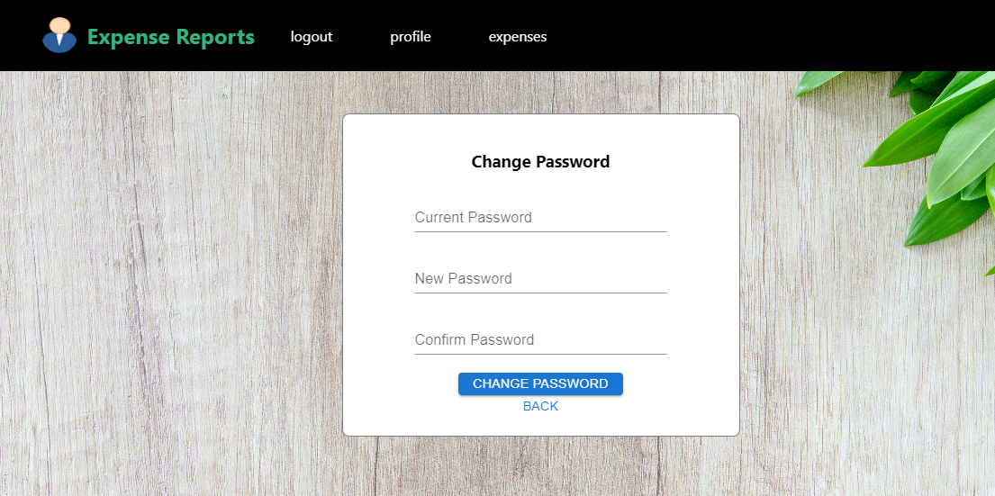

* 1. Expenses

Expenses page is the main module of the application which allows user to create edit and delete the expense. Once the page is loaded the user is able to see the table with all current expenses. At the top level there is filter section where user can get the filtered from the backend data presented in the table.  
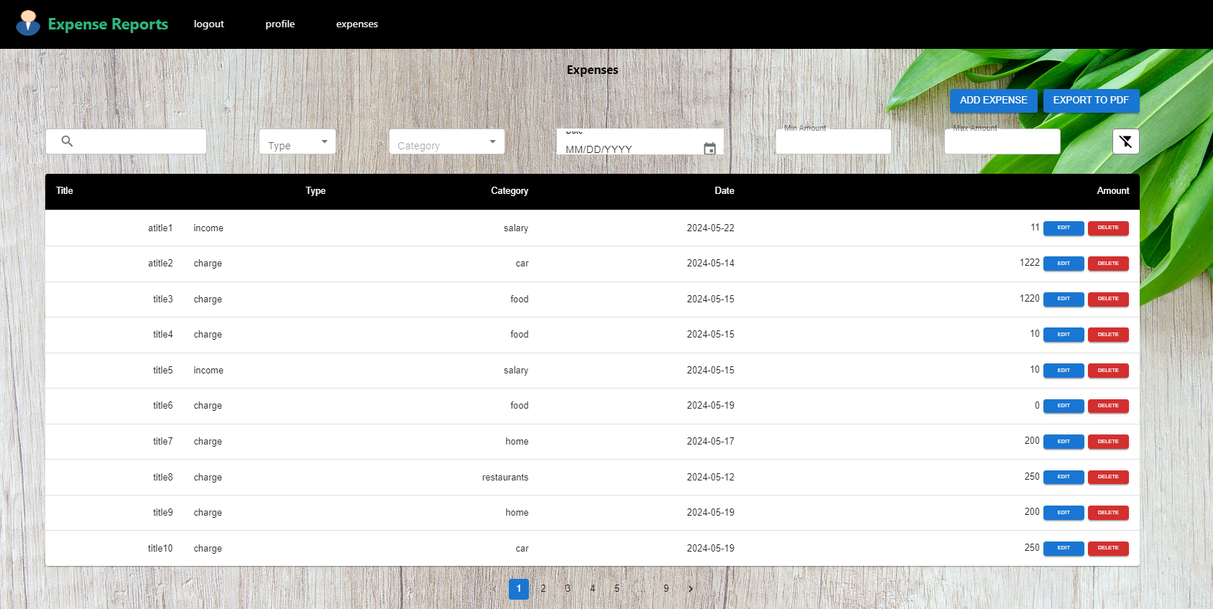  
before the filter section there are two buttons which allow to add expense and download the pdf expense report.  
Here is the template of the downloaded pdf report:  
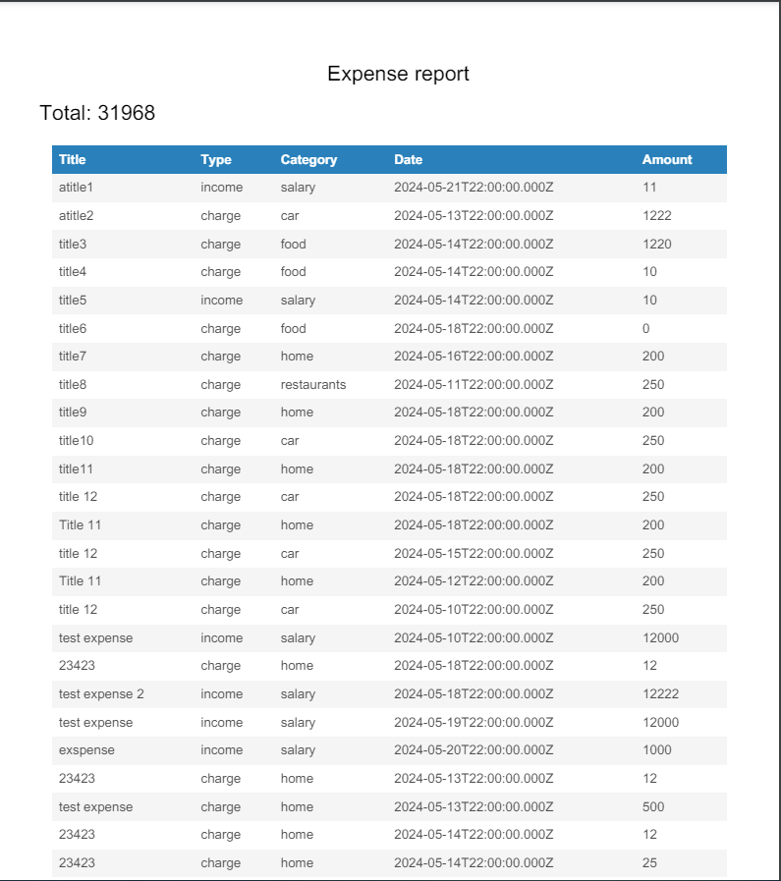  
The report counts the total sum which is based on type of the expense is it income or charge so the total amount could be negative as well in case the user will have more charges than incomes.

1. Summary

The Expense Management Application project integrates modern web technologies to provide a practical tool for user to manage their finances effectively. By combining React, Node.js/Express, and MySQL, the application delivers a seamless, responsive, and secure user experience. This project not only enhances students' financial literacy but also provides valuable hands-on experience with full-stack development.